

Module Leader = NoorSyamimi HJ Abdur Ajak

Word count = words

LCB ID = 6376

ESSEX ID = HAJIA11719

MODULE CODE AND TITLE = CS4127/ Web Development

GitHub Link: https://github.com/Mdawg78/Assignment-1?tab=readme-ov-file#assignment-1

Wireframe
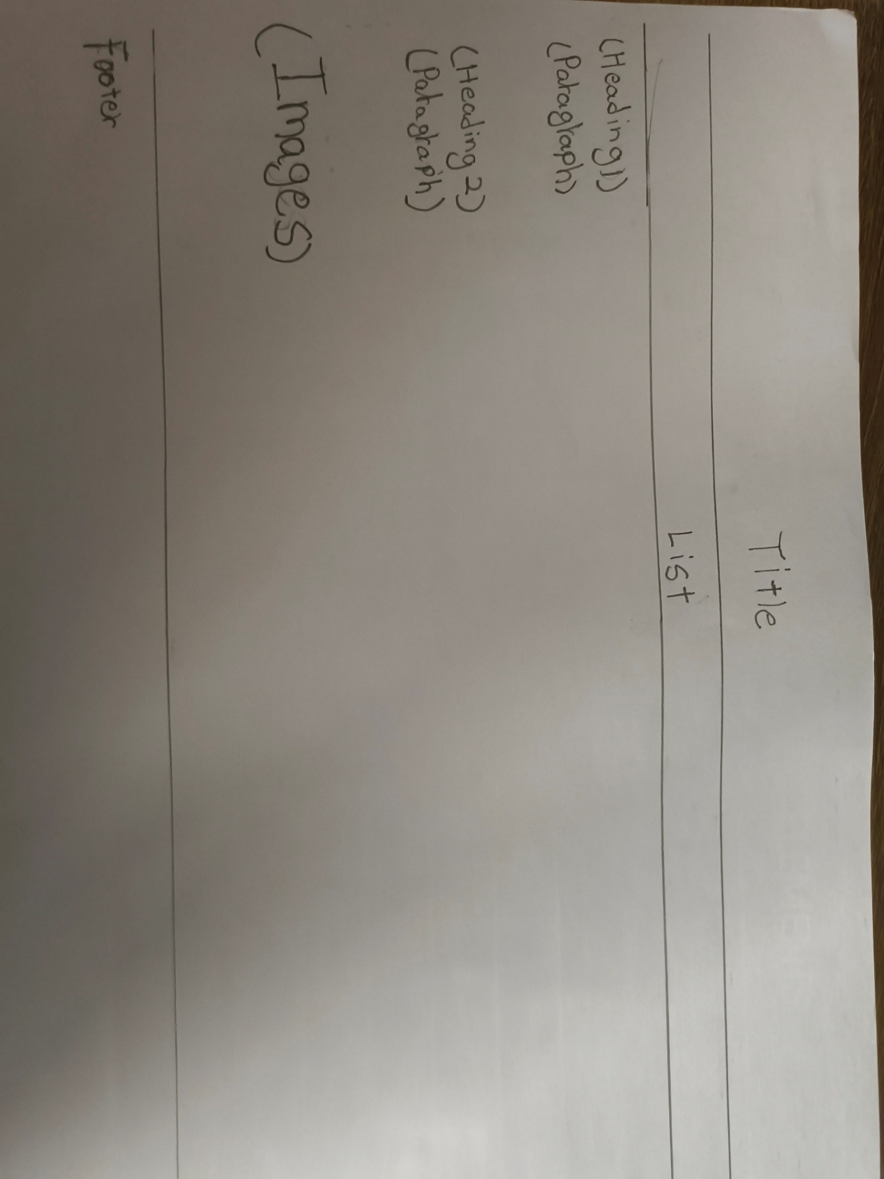

The wireframe above is what I used as a reference for all my webpages. I prepared a format that could be replicated in all my webpages. The wireframe above contains a title that is specially positioned to grab attention, a list for all the webpages, heading and paragraphs to input content, images to represent the topic and a footer.
The first step of building the website was creating all the necessary files such as the html, CSS and JavaScript. Next, input all the necessary codes that give my webpages structure like head, body and etc. After that, the content related to the topic were put in one by one while researching the all the necessary information.
The second step is to input the CSS style for all my webpages, so that the webpages look more appealing and welcoming. The CSS style added to the webpages are the image size, background image, text-align, font family and much more.
The third step was filling in the JavaScript file to create better interactive features for the webpages and for users to interact with the webpage more.
I tested my webpages by launching it on a browser and refreshing after every change in the html, CSS or JavaScript, doing this helps to check if the changes made are good, working and improves the webpage. There are also websites that help check whether or not the webpages are working on other devices.
There are JavaScript features that have implemented in the webpages. The first feature is a print menu, specifically placed on the webpages with main topics to enhance user experience as users that are intrigued about the information and users that need it for educational purposes might need it. This feature requires only the click of a button to activate the print menu.
The second feature is a button that highlights the title of a webpage. This feature encourages users to interact with the website and grab their attention and keep users around longer.
The third feature is interactive images. Interactive images allows the webpage to hold multiple images in one area without taking up a lot of space. This is useful as it only requires users to swipe left or right to look at multiple images and give them an idea of what the topic is referring to that the users may not have grasped at first.

Reference List –
Brown, L. (2025) “Songkran: The world’s biggest water fight,” BBC, 13 April. Available at: https://www.bbc.com/travel/article/20250411-songkran-the-worlds-biggest-water-fight.

Bullard, E.C. (2023) Research starters, EBSCO. Available at: https://www.ebsco.com/research-starters/religion-and-philosophy/matariki.

Song, W. and Howell, J. (2022) “Lunar New Year: What is it and how is it celebrated?,” BBC, 28 January. Available at: https://www.bbc.com/news/world-60153348.

